

**Department of Artificial Intelligence**

**College of Computer Science and Information Technology**

1. **Objectives**
2. Understanding Image Restoration

**Due Date: Tuesday October 30, 2024 @ 11:59 PM**

**Late Submissions:**

* Q: Can I skip the lab and submit the solution?
  + You will receive a mark of **zero** if you do not attend the lab, even if you complete the exercise. Attending the labs is compulsory for evaluation. If you have a justified excuse, you may receive a partial mark depending on the circumstances. See the next question for information on late submissions.
* **Q:** If I submit it at 12:00am, you’ll still mark it, right?
  + **A:** 11:59pm and earlier is on time. Anything after 11:59pm is late. Anything late will **NOT** be probably marked. If I find you have a legitimate cause, you will be graded according to the following rules (24 hours after deadline 🡪 assignment is marked out of 75% only, 48 hours after deadline 🡪 assignment is marked out of 50% only, 72 hours after deadline 🡪 assignment is marked out of 25% only)

1. **Introduction**

Image Restoration is a process that uses prior knowledge to reconstruct the image that has been degraded. Similar to the enhancement technique, the function of the restoration technique is to improve the image, using priori knowledge and applying the inverse process in order to restore the original image.

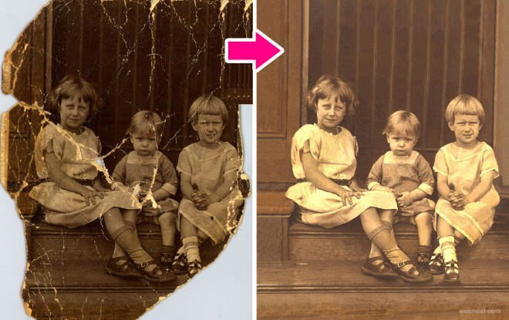

**Denoising and general reconstruction**

Image denoising refers to an attempt to restore images contaminated by additive noise or sources such as compression.

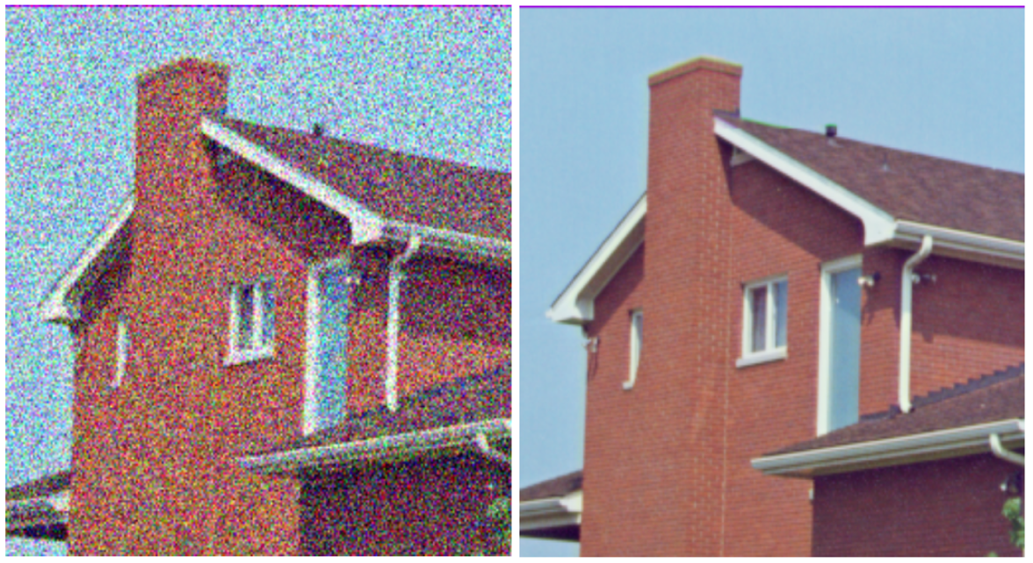

(Left) Noisy Image, (Right) Denoised Image

**Super — resolution**

The goal of super-resolution is to take a low-resolution image and up-sample it to create a high-resolution version.

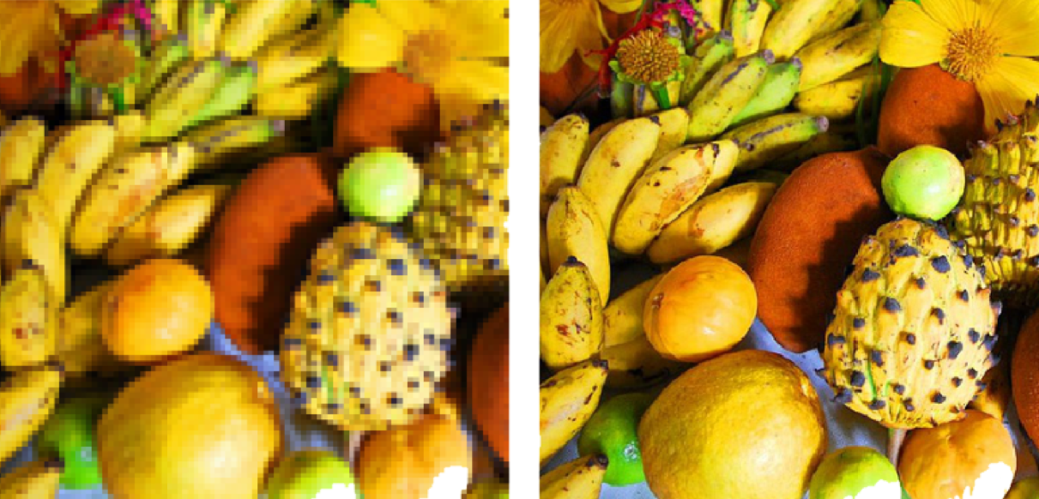

(Left) Low-Resolution Image, (Right) High-Resolution Image

**Image restoration**

* Image reconstruction
  + Fixing damaged images
  + Text removing
  + Logo removing
  + Object removing
* Inpainting
  + Reconstructing lost parts of images
  + Looking at the non-damaged regions

**Let's restore a damaged image**

In this exercise, we'll restore an image that has missing parts in it, using the inpaint_biharmonic() function.

We'll work on an image with damaged. Some of the pixels have been replaced by 1s using a binary mask, on purpose, to simulate a damaged image. Replacing pixels with 1s turns them totally black.

The mask is a black and white image with patches that have the position of the image bits that have been corrupted. We can apply the restoration function on these areas.

Remember that inpainting is the process of reconstructing lost or deteriorated parts of images and videos.

**def** **show_image(**image**,** title**=**'Image'**,** cmap_type**=**'gray'**):**

plt**.**imshow**(**image**,** cmap**=**cmap_type**)**

plt**.**title**(**title**)**

plt**.**axis**(**'off'**)**

**def** **plot_comparison(**img_original**,** img_filtered**,** img_title_filtered**):**

fig**,** **(**ax1**,** ax2**)** **=** plt**.**subplots**(**ncols**=**2**,** figsize**=(**10**,** 8**),** sharex**=True,** sharey**=True)**

ax1**.**imshow**(**img_original**,** cmap**=**plt**.**cm**.**gray**)**

ax1**.**set_title**(**'Original'**)**

ax1**.**axis**(**'off'**)**

ax2**.**imshow**(**img_filtered**,** cmap**=**plt**.**cm**.**gray**)**

ax2**.**set_title**(**img_title_filtered**)**

ax2**.**axis**(**'off'**)**

from skimage.restoration import inpaint

from skimage.transform import resize

from skimage import color

defect_image **=** plt**.**imread**(**'./dataset/damaged_astronaut.png'**)**

defect_image **=** resize**(**defect_image**,** **(**512**,** 512**))**

defect_image **=** color**.**rgba2rgb**(**defect_image**)**

mask **=** pd**.**read_csv**(**'./dataset/astronaut_mask.csv'**).**to_numpy**()**

*# Apply the restoration function to the image using the mask*

restored_image **=** inpaint**.**inpaint_biharmonic**(**defect_image**,** mask**,** multichannel**=True)**

*# Show ther defective image*

plot_comparison**(**defect_image**,** restored_image**,** 'Restored image'**)**

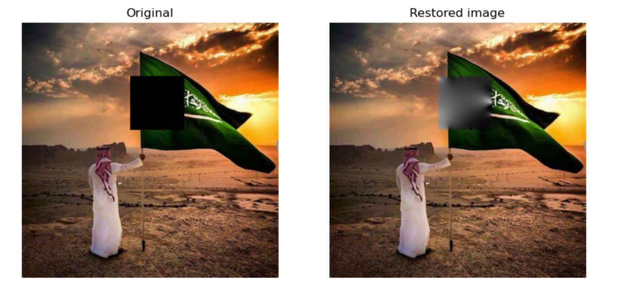

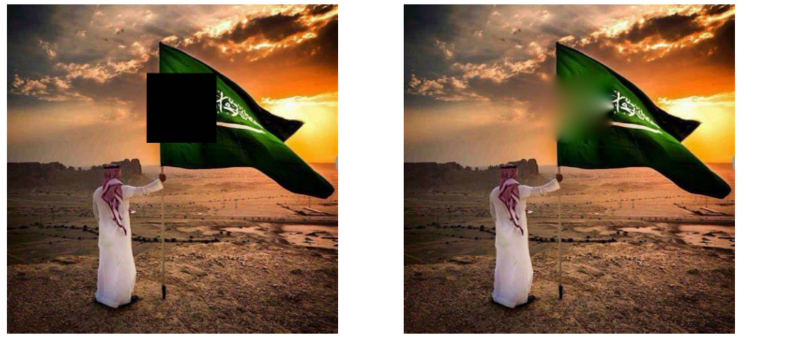

**Removing logos**

As we saw in the video, another use of image restoration is removing objects from an scene. In this exercise, we'll remove the Datacamp logo from an image.

You will create and set the mask to be able to erase the logo by inpainting this area.

Remember that when you want to remove an object from an image you can either manually delineate that object or run some image analysis algorithm to find it.

image_with_logo **=** plt**.**imread**(**'./dataset/4.2.06_w_logo_2_2.png'**)**

*# Initialize the mask*

mask **=** np**.**zeros**(**image_with_logo**.**shape**[:-**1**])**

*# Set the pixels where the logo is to 1*

mask**[**210**:**272**,** 360**:**425**]** **=** 1

*# Apply inpainting to remove the logo*

image_logo_removed **=** inpaint**.**inpaint_biharmonic**(**image_with_logo**,**

mask**,**

multichannel**=True)**

*# Show the original and logo removed images*

plot_comparison**(**image_with_logo**,** image_logo_removed**,** 'Image with logo removed'**)**

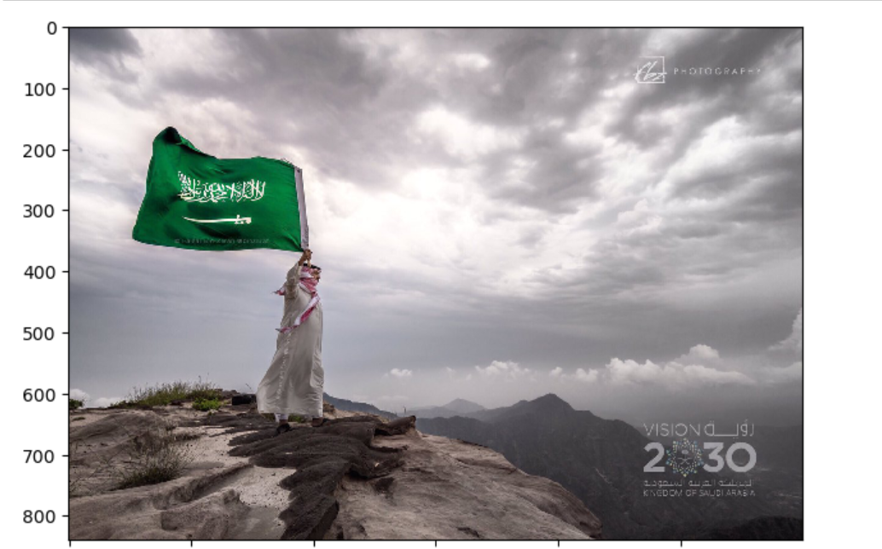

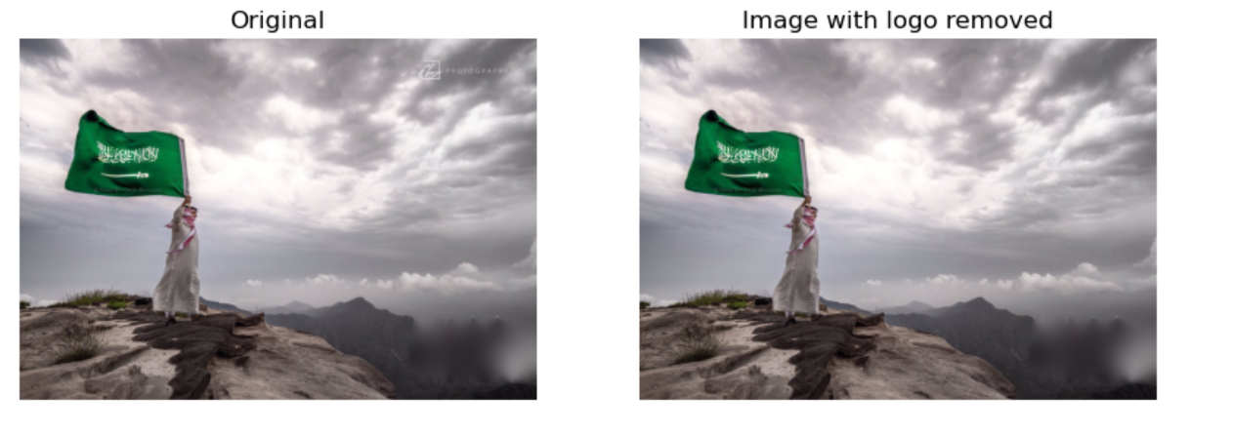

**Noise**

* Denoising types
  + Total variation (TV)
  + Bilateral
  + Wavelet denoising
  + Non-local means denoising

**Let's make some noise!**

In this exercise, we'll practice adding noise to a fruit image.

from skimage.util import random_noise

fruit_image **=** plt**.**imread**(**'./dataset/fruits_square.jpg'**)**

*# Add noise to the image*

noisy_image **=** random_noise**(**fruit_image**)**

*# Show th original and resulting image*

plot_comparison**(**fruit_image**,** noisy_image**,** 'Noisy image'**)**

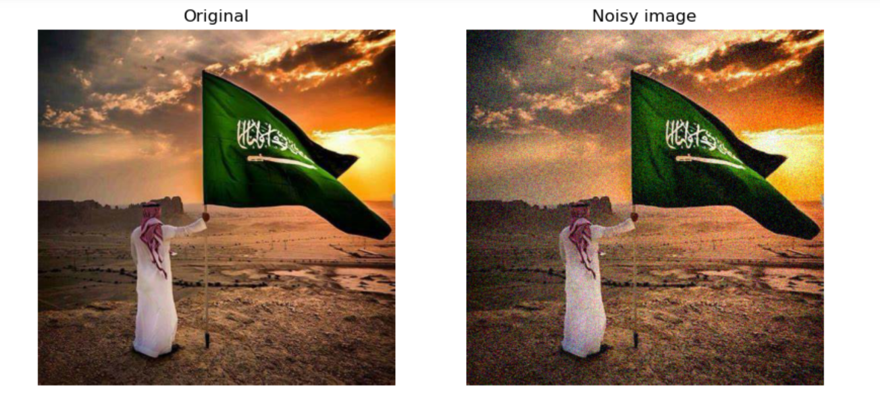

**Reducing noise**

We have a noisy image that we want to improve by removing the noise in it.

Use total variation filter denoising to accomplish this.

from skimage.restoration import denoise_tv_chambolle

noisy_image **=** plt**.**imread**(**'./dataset/miny.jpeg'**)**

*# Apply total variation filter denoising*

denoised_image **=** denoise_tv_chambolle**(**noisy_image**,** multichannel**=True)**

*# Show the noisy and denoised image*

plot_comparison**(**noisy_image**,** denoised_image**,** 'Denoised Image'**)**

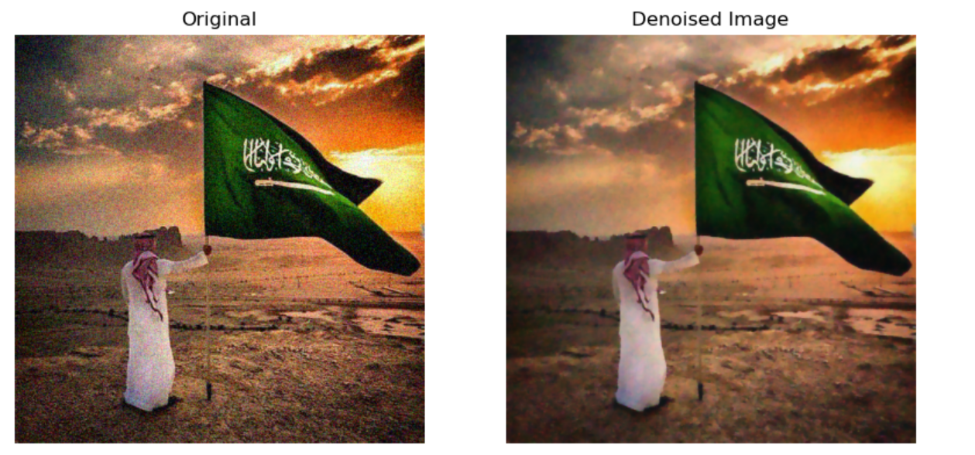

# References

<https://python.plainenglish.io/introduction-to-image-processing-with-python-18fec2d8dff8>